**Install Apache Tomcat:**

1. Download Tomcat packages onto /opt on Server

# create a tomcat directory

/opt

2. After place the zip file onto /opt directory, unzip the folder

#unzip apache-tomcat-8.5.41.zip

3. Rename the unzip apache-tomcat-8.5.41 to tomcat

# mv apache-tomcat-8.5.41 tomcat8.5

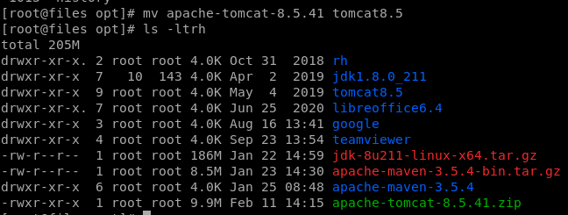

4. Give execute permissions to startup.sh and shutdown.sh which are under /bin

# chmod +x /opt/tomcat8.5/bin/startup.sh

#chmod +x /opt/tomcat8.5/bin/shutdown.sh



#ls -ltrh - - > See the file permissions



5. Start the tomcat server

# ./startup.sh

Here encounter the error while start the tomcat server as like below screen shot.

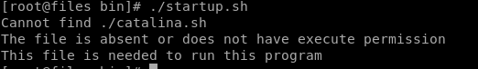

For trouble shoot the issue make give execute permissions to catalina.sh

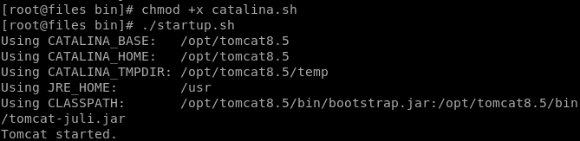

6. Check the tomcat is running or not

# ps -ef | grep tomcat

7. check point:

Access the tomcat in browser

http://<public_ip>:8080/

8. Change the port or access multiple port of tomcat8.5



* Go to the path of tomcat : /opt/tomcat8.5/conf

Here you can edit ‘server.xml’ file

* We can change the connector port or we can add the multiple connector properties with different port.

9. To effect the change , restart the tomcat and access from the browser.